ELECTRODE PLACEMENT

Sensors placed using 10-20 system for mid sized adult head (~40th percentile)

* Positions expand wider for larger sizes but still approximately correct if carefully fitted
  + Minor variation is ok
* Self- assessment:
  + Use the brain activity map and EMOTIV control panel to see brain activity with corresponding locations

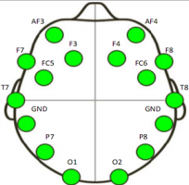

NAMES OF EMOTIV SENSORS AND THEIR LOCATIONS ON THE SCALP 
Sensor # 
2 
3 
4 
5 
6 
7 
8 
9 
10 
11 
12 
13 
14 
15 
16 
Sensor Name 
AF3 
AF4 
FC6 
DRL (reference 
02 
01 
CMS (reference 
FCS 
Area of the Brain 
Dorsolateral refrontal cortex 
Frontal e e fields 
Dorsolateral refrontal cortex 
Frontal e e fields 
Anterior refrontal cortex 
Dorsolateral refrontal cortex 
Prim 
tato cortex 
Middle tem oral rus 
Pri 
motor cortex 
Somatosens association cortex 
Somatosens association cortex 
Pri 
motor cortex 
Middle tem oral rus 
Prim 
tato cortex 
Anterior refrontal cortex 
Dorsolateral refrontal cortex 

Or you can manually measure and choose locations

<https://www.trans-cranial.com/local/manuals/10_20_pos_man_v1_0_pdf.pdf>